**Lab Exercise - 3**

**[Based on Python Data Types (String, List, Tuple & Conditional statements]**

Q1: Write a Python program to sum all the items in a list.

Q2: Write a Python program to get the largest number from a list.

Q3: Write a Python program to get the smallest number from a list.

Q4: Write a Python program to display the first and last colors from the following list.

color_list = ["Red","Green","White" ,"Black"]

Q5: Write a Python program to add 'ing' at the end of a given string (length should be at least 3). If the given string is already ends with 'ing' then add 'ly' instead.

Q6: The marks obtained by a student in 5 different Subjects are input through a keyboard. The Student gets a division as per the following rules.

1. Percentage above or equal to 60 – First Division
2. Percentage between 50 and 59 – Second Division
3. Percentage between 40 and 49 – Third Division
4. Percentage less than 40 – Fail

Write a python program to Display the result based on the above Criteria.

Q7: write a Python program to find the largest number among the three input numbers

Q8: Write a Python program to check if the input year is a leap year or not.

Q9: write a Program to check if a string is palindrome or not

Q10: write a Program to sort alphabetically the words form a string provided by the user. [You can use split() method to split string into a list of words. ]

Q11: Given a nested list. Write a python program to extend it with adding sub list ["h", "i", "j"] in a such a way that it will look like the following list

Given List:

list1 = ["a", "b", ["c", ["d", "e", ["f", "g"], "k"], "l"], "m", "n"]

Sub List to be added = ["h", "i", "j"]

Expected output:

['a', 'b', ['c', ['d', 'e', ['f', 'g', 'h', 'i', 'j'], 'k'], 'l'], 'm', 'n']

Q12: Write a python program for Given a Python list, to find value 20 in the list, and if it is present, replace it with 200. Only update the first occurrence of a value

list1 = [5, 10, 15, 20, 25, 50, 20]

Expected output:

list1 = [5, 10, 15, 200, 25, 50, 20]

Q1: Write a python program to add all the odd numbers from 0 to 20.

Q 2: Write a python program to find the sum of all integers greater than 100 and less than 200.

Q3: Write a program to display the sum of square of the first ten even natural numbers

Q4: Write a python program to display ascii characters from 65 to 90

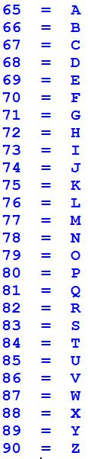

Q5: Display ascii characters from 48 to 57.

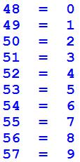

Q6: Display the following output with the help of Ascii character.

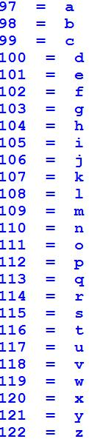

Q7: Write a python program for given a Python list you should be able to display Python list in the following order

L1 = [100, 200, 300, 400, 500]

Expected output:

[500, 400, 300, 200, 100]

Q8: Write a Python program to concatenate following dictionaries to create a new one.

Sample Dictionary :   
dic1={1:10, 2:20}   
dic2={3:30, 4:40}   
dic3={5:50,6:60}  
Expected Result : {1: 10, 2: 20, 3: 30, 4: 40, 5: 50, 6: 60}

Q9: Write a Python program to add key to a dictionary.

Sample Dictionary : {0: 10, 1: 20}  
Expected Result : {0: 10, 1: 20, 2: 30}

Q10: Write a Python program to print out a set containing all the colors from a list which are not present in another list

Test Data :

color_list_1 = set(["White", "Black", "Red"])   
color_list_2 = set(["Red", "Green"])

Q11: Given a Python list. Write a python program to turn every item of a list into its square List1 = [1, 2, 3, 4, 5, 6, 7]

Expected output:

[1, 4, 9, 16, 25, 36, 49]

Q12: Program to count the number of each vowel in a string.

Q14:Write a python program to Access the value of key ‘history’ from the following dictionary-sampleDict = {

"class":{

"student":{

"name":"Mike",

"marks":{

"physics":70,

"history":80

}

}

}

}

**[Nested Loops]**

Q16: Write a python program to print the Following:



**Q17: WAP to print the following asterisk pattern:**

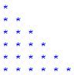

**Q18: WAP to create a function traiangle to print the following asterisk triangle pattern:**



**Q19: Write a python program to print following multiplication table on the screen**

